Customer Bill of Exchange Discounting

Method 1 : Simple

S.NO. : 02- FI-AR- 07

TRANSACTION CODE : F – 33

ACCESS PATH :SAP Easy Access Accounting Financial
Accounting Accounts Receivable Document Entry
Bill of Exchange Discounting

We get “ Post Bill of exchange Usage – Header Data” Screen as under;

Required Fields:

Document Date : To be entered
Usage : To be set at “ Discounting”
Bank Account : To be entered
Clearing Account : To be entered (eg: 29501- CBI Bill Discounting A/c)
Amount : To be entered after considering the Discount Charge
Bank Charges : Enter the discount Charges
Posting date : Default

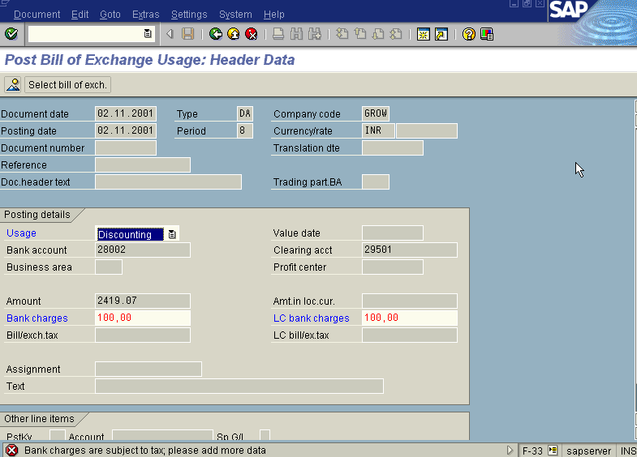
Document Type, Currency, Period & Company code appear as default after it has been entered for the first time.

Press enter Button

We get “Tax Data” Screen press Continue Button in this screen twice

Press Select Bill of Exchange Button

We get “ Post Bill Of Exchange Usage: Choose Postings” Screen as Under

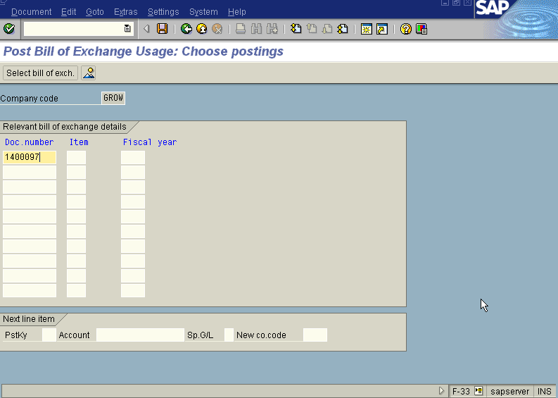
In the above Screen fill the bill of exchange Doc. Number

Press Enter Button

The System Displays the Messsage as under

Press Save Button

The system displays the message as under

Take the note of the document number : 1600090.

To view the entries posted go to “Post Bill of Exchange Usage – Header data” screen
And click Document Display or press Transaction Code FB03.

We get the Overview document screen with the entries as under
